|  |
| --- |
| rEGGAErunningz LIMITED |
| ROBOTS VS ALIENS |
| **GAME PROGRAMMING1 FINAL PROJECT** |
| Version 1.05  All work Copyright © 2015 by ReggaeMuffinz Games.  All rights reserved. |
| **HuAndre Barrett** |
|  |



**Insert a Company Logo here**

|  |
| --- |
| Dec 4th 2015 |

**Table of Contents**

Contents

Version History 3

Game Overview 4

Game Play Mechanics 4

Camera 4

Controls 4

Menu and Screen Descriptions 5

Enemies 5

Items 5

Vehicles 5

Script 6

Scoring 6

Sound Index 6

Art / Multimedia Index 6

Future Features 6

# Version History

The Github repository can be found here https://github.com/cencolhubar/finalProj

# Game Description

*The game is a 2d Platformer game where the hero is a Robot who must defeat the evil Aliens who have invaded the planet. The hero is constantly being attacked by Aliens while advancing through the game. He must shoot and destroy them and then eventually kill the Boss Alien at the end of the level. You have to shoo the boss ten times to complete the level.*

*The object of the game is for the Robot to avoid being killed by the Aliens, defeat the Aliens by shooting and destroying them and collect the stars which are left every time he kills an alien.*

# Game Play Mechanics

*The game automatically gives the illusion of side scrolling by looping the background texture around the quad. You can use the left, right, up or down arrow to move the player in any direction. As you move around you will see aliens appearing on the screen and advancing towards the player as it scrolls. Use the left ctrl button to shoot at the aliens and the space button to make the Robot jump. If the Robot collides with the Aliens he will lose a life. If the Robot falls down into the abyss you will also lose a life and be reborn. There are platforms that have hearts on top of them. If you collect the hearts you will get additional lives. When you have zero lives you die and the game is over. Press R to restart. When you kill an Alien a star is left behind. Collect the stars. Every time you collect two stars you will get an Alien non player character ally in a spaceship. This Ally will kill aliens for you by crashing his spaceship into the aliens. When birds are collected your points increase. Your points are displayed on your screen as you play.*

# Camera

*Side Scrolling view perspective*

# Controls

*Arrow keys to direct the Robot*

*Left Ctrl to shoot*

*Space to Jump*

Levels

*The first level is an outdoor level where the Robots fights the Aliens with the stars scrolling in the background. The Robot runs from platform to platform until he reaches the boss.The level is dynamically generated each time so the player will have to find different ways to get through the level each time*

*The second level will be an indoor level where the Robot is in the Aliens “nest” and has to find the Alien Queen and kill her. The complexity of the level will be increased over the first one by with the platforms actually moving up and down while the robot is moving. So the player has to time his jumps and movement between platforms.*

*The third level will be where the Robot actually commandeers one of the Alien Robot Ships and takes to the skies to battle it out. There will be an epic spaceship battle to the end between the Robot and the Aliens. The Robot will have to shoot the Alien Spaceships and also avoid being shot*

# Enemies

*The Aliens that can kill the player if collided with*

*The Enemy boss*

# Items

*The Robot collects heart to increase his life and points*

*The robot collects stars to gain a NPC Alien ally*

# Player

The main player is the Robot

# Script

C:\ Final Project\Assets\_Scripts

# Wireframes

# Level 1

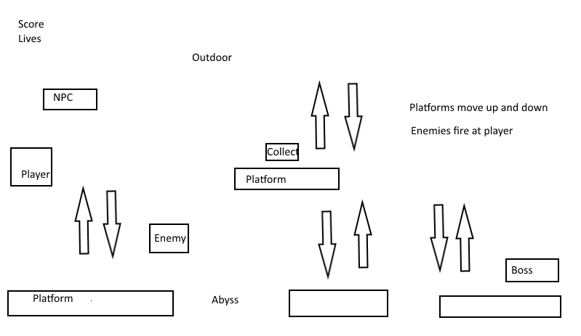

# Level 2

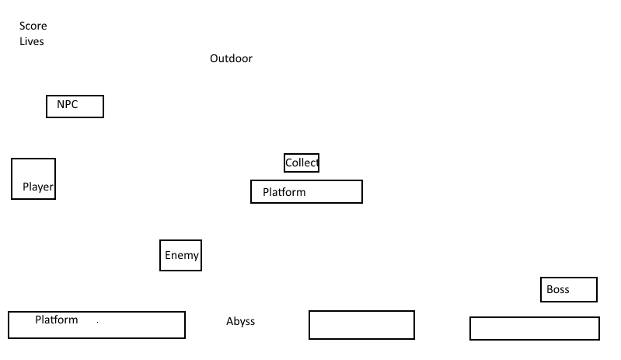

# Level 3

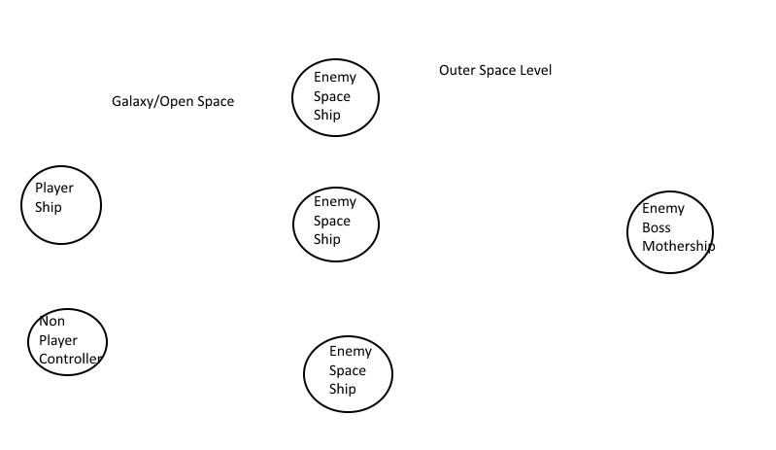

# Scoring

Player points and life increase by 1 each time the Robot collects a heart

Player points increase by 1 each time the Robot collects a star

# Sound Index

.. Final Project*Assets\Audio*

# Art / Multimedia Index

*The following graphic assets were taken from unity 3d store from the following resources*

***Background***



**Shot**C:\Users\PATRICK\Documents\Hu Projects\Game Programming\Final Project\Assets\Textures\singleshot.png

**Life pickup** 

**Robot**

# Future Features

*Implementation of two additional levels*

1. *Indoor level where the player fights inside the Alien nest*
2. *Flight level where Robot is in a spacecraft*